Name - Ashish Kothari Course – BCA(II)
Roll No. - 17 Section – D1
Subject - Advance concepts of C programming Subject Code – PBC 202

// Problem Satement (44) - WAP to swap to number using call by reference in structure.
// Objective – to swap to number using call by reference in structure.
#include <stdio.h>

struct Numbers {
int n1;
int n2;
};

void swapNumbers(struct Numbers *numbers) {
int temp = numbers->n1;
numbers->n1 = numbers->n2;
numbers->n2 = temp;
}

int main() {
struct Numbers num;
printf("Enter the first number: ");
scanf("%d", &num.n1);
68

printf("Enter the second number: ");
scanf("%d", &num.n2);

printf("Before swapping: num1 = %d, num2 = %d\n", num.n1, num.n2);
swapNumbers(&num);
printf("After swapping: num1 = %d, num2 = %d\n", num.n1, num.n2);

return 0;
}
// Output:
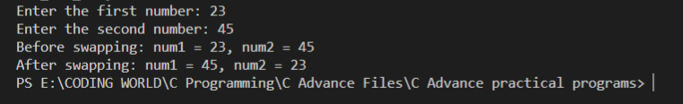

69

Name - Ashish Kothari Course – BCA(II)
Roll No. - 17 Section – D1
Subject - Advance concepts of C programming Subject Code – PBC 202

// Problem Satement (45) - WAP to display the total size occupied by the union.
// Objective – To display the total size occupied by the union.
#include <stdio.h>
union MyUnion {
int integer;
float floatingPoint;
char character;
};

int main() {
union MyUnion myUnion;

size_t unionSize = sizeof(myUnion);

printf("The size of the union is: %d bytes\n", unionSize);

return 0;
}

70

// Output:

71

Name - Ashish Kothari Course – BCA(II)
Roll No. - 17 Section – D1
Subject - Advance concepts of C programming Subject Code – PBC 202

// Problem Satement (46) - WAP progarm to find the largest of three no using array of poiter.
// Objective - To find the largest of three no using array of poiter.
#include <stdio.h>
int findLargest(int *numbers[]) {
int largest = *numbers[0];

for (int i = 1; i < 3; i++) {
if (*numbers[i] > largest) {
largest = *numbers[i];
}
}

return largest;
}

int main() {
int num1, num2, num3;
int *numbers[3];
printf("Enter the first number: ");
72

scanf("%d", &num1);

printf("Enter the second number: ");
scanf("%d", &num2);

printf("Enter the third number: ");
scanf("%d", &num3);

numbers[0] = &num1;
numbers[1] = &num2;
numbers[2] = &num3;

int largest = findLargest(numbers);

printf("The largest number is: %d\n", largest);

return 0;
}
// Output:
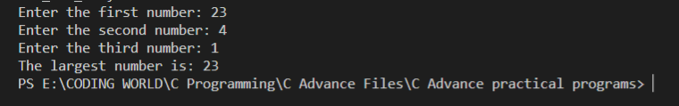

73

Name - Ashish Kothari Course – BCA(II)
Roll No. - 17 Section – D1
Subject - Advance concepts of C programming Subject Code – PBC 202

// Problem Satement (47) -. WAP program to check whether the number is odd or even using bitwise operator.
// Objective - To check whether the number is odd or even using bitwise operator.
#include <stdio.h>
void checkOddEven(int num) {
if (num & 1) {
printf("%d is an odd number.\n", num);
} else {
printf("%d is an even number.\n", num);
}
}

int main() {
int number;

printf("Enter a number: ");
scanf("%d", &number);

checkOddEven(number);
74

return 0;
}
// Output:
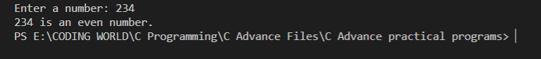

75

Name - Ashish Kothari Course – BCA(II)
Roll No. - 17 Section – D1
Subject - Advance concepts of C programming Subject Code – PBC 202

// Problem Satement (48) -. WAP to demonstrate the use of all the bultin function of <string.h>.
// Objective - To demonstrate the use of all the bultin function of <string.h>.
#include <stdio.h>
#include <string.h>

int main() {
char str1[20] = "Hello";
char str2[20] = "World";
char str3[20];
char str4[20] = "Hello";
char str5[20] = "WORLD";
char str6[20] = "World";

printf("Length of str1: %d\n", strlen(str1));

strcpy(str3, str1);
printf("str3 after strcpy: %s\n", str3);
strcat(str1, str2);
printf("str1 after strcat: %s\n", str1);
76

int cmpResult = strcmp(str4, str5);
printf("Result of strcmp(str4, str5): %d\n", cmpResult);

char *chPtr = strchr(str6, 'r');
printf("Pointer returned by strchr: %p\n", chPtr);

char *substrPtr = strstr(str1, "World");
printf("Pointer returned by strstr: %p\n", substrPtr);

strncpy(str3, str1, 5);
printf("str3 after strncpy: %s\n", str3);

strncat(str3, str2, 3);
printf("str3 after strncat: %s\n", str3);

int nCmpResult = strncmp(str4, str5, 3);
printf("Result of strncmp(str4, str5, 3): %d\n", nCmpResult);

char *lastChPtr = strrchr(str6, 'r');
printf("Pointer returned by strrchr: %p\n", lastChPtr);

memset(str3, '*', 5);
77

printf("str3 after memset: %s\n", str3);
memcpy(str3, str4, 5);
printf("str3 after memcpy: %s\n", str3);

return 0;
}
// Output:
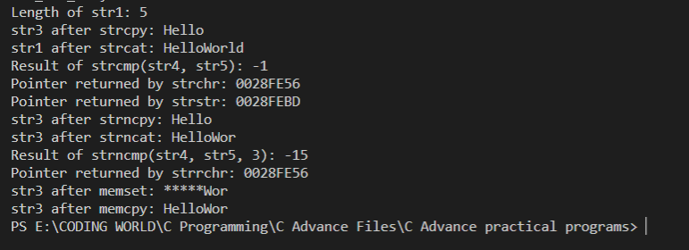

78

